Line Chart Activity
- Open a new Excel document.
- Copy the information in the chart below:

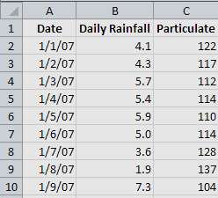

- Select the data that you want to plot in the line chart.
- On the Insert tab, in the Chart group, click Line.
- Click Line with Markers.
- To plot the Daily Rainfall column on a secondary vertical axis, click the data series for Rainfall, or select it from a list of chart elements (Layout tab, Current Selection group, Chart Elements box).
- On the Layout tab, in the Current Selection group, click Format Selection.
- Under Series Options, select Secondary Axis, and then click Close.
- On the Layout tab, in the Labels group, click Axis Titles.
- Click Primary Vertical Axis Title and name it Particulate Level, making sure to use Rotated Title.
- Click on Secondary Vertical Axis Title and name it Daily Rainfall, again using the Rotated Title.
- On the Layout tab, in the Labels group, click Chart Title, and then click Above Chart.
- Click the chart title, and then name it Particulate Levels in Rainfall, and reduce the size of the title to 14.
- When you’re finished, your chart should look like the one below:
